**CSC 117 – Introduction to Computer Science**

**Lab 12 – The Flight of the Giant Gummy Bear**

This lab has several purposes.

* It will give you practice taking a problem statement like the one below and determining what information is missing from the problem statement (if any) that you need to solve the problem.
* It will give you practice creating a flowchart and/or pseudocode to solve a bigger problem than the simple ones at the end of the chapter. You should expect to see problems of this magnitude on exams, in addition to the simpler types of problems you see on daily quizzes and chapter tests.
* It will force you to apply most of what you have learned this semester to a single problem. That will require you to think about the tools and techniques you have learned and string several of them together to construct a correct solution.
* It will give you the opportunity to both teach and learn from your classmates. You will be able to see how they attack problems and they will see how you go about solving problems. If you are a strong problem solver, this may force you to learn patience and how to communicate with others and teach them. If you have difficulty solving problems, you will benefit from the experience by understanding what your teammates are doing, and more importantly, WHY they are doing those things. Don’t let them just leap ahead without you! Make sure you understand!

**In this lab, you will simulate the flight of a Giant Gummy Bear from the top of a launch pad toward a target about 100 feet away. The GUI you build will allow the user to set the launch angle and velocity as text values and then commence the launch with a button click. The simulation will then show the flight path of the Giant Gummy Bear until it lands on the target, strikes the ground, or passes beyond the "airspace" of the playing field. The simulator will conclude by reporting whether the user won or lost, then terminate.**

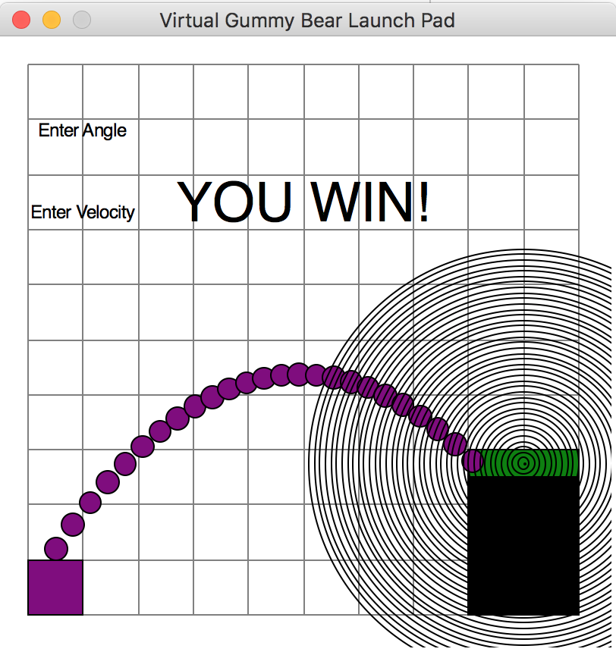

Step 1: Each person should create a list of any pieces of information that you believe that you will need to solve the problem that you were not given in the problem statement. When you have created your list and feel like you have listed out everything you will need, turn your paper over and wait for your professor to tell you to continue.

___________________________________________________________________________________

___________________________________________________________________________________

___________________________________________________________________________________

___________________________________________________________________________________

___________________________________________________________________________________

Step 2: As a team of 2, discuss the items you had on your lists. If your partner had something you didn’t, ask why. Perhaps they were right and you need it, or perhaps not. Create a list that you both agree on and make sure you both have a copy of it here:

___________________________________________________________________________________

___________________________________________________________________________________

___________________________________________________________________________________

___________________________________________________________________________________

___________________________________________________________________________________

___________________________________________________________________________________

Step 3: When you have agreed upon a list, signal the professor that your team is ready to proceed. When all the teams are ready, we will discuss the lists together as a class. Perhaps another team thought of something extra you don’t need or something else you do need. Add anything your team was missing in the space below.

___________________________________________________________________________________

___________________________________________________________________________________

___________________________________________________________________________________

___________________________________________________________________________________

Step 4: Now you should plan how to solve the problem. As a pair, develop a flowchart and/or pseudocode for your program. Do NOT have one person do one part while the other does the other part. You BOTH need to be involved in both parts. The purpose of this is to build skills, not to “get it done” or “grab points.” There are no prizes or extra points for speed here. Using the scrap paper, develop your flowchart and/or pseudocode. When you have finished one, discuss it with your professor. Make any necessary modifications, and then have each member copy the version your team agrees upon onto this handout.

Flowchart/Pseudocode